Travel Memory Documentation
Phase1: Initial Setup and Cloning Repo
1.1 create ec2 instance key-pair.pem
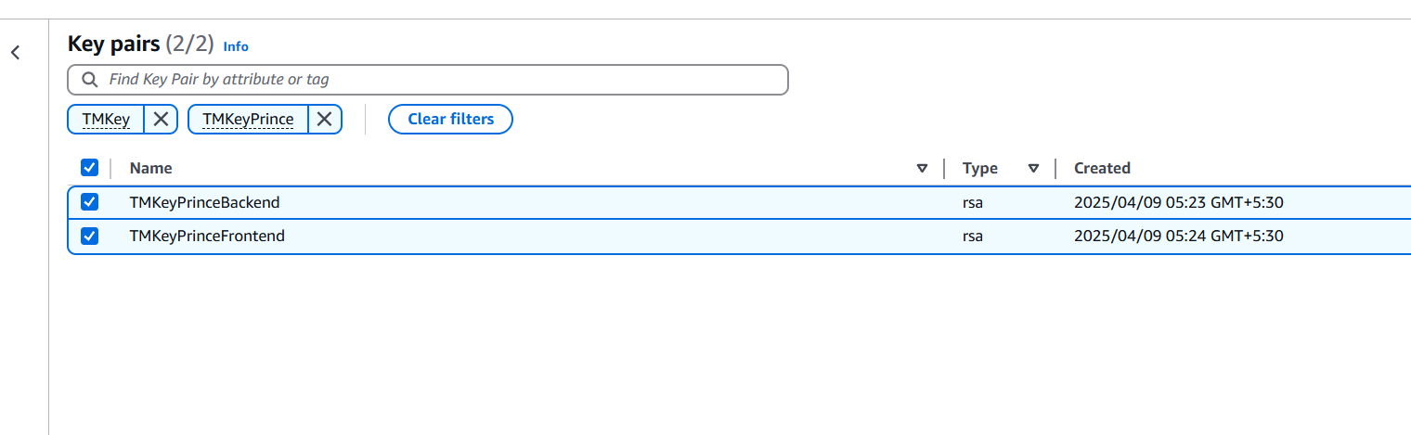

1.2 Launch EC2 Instances with Elastic IP for Backend Frontend:
- Backend:
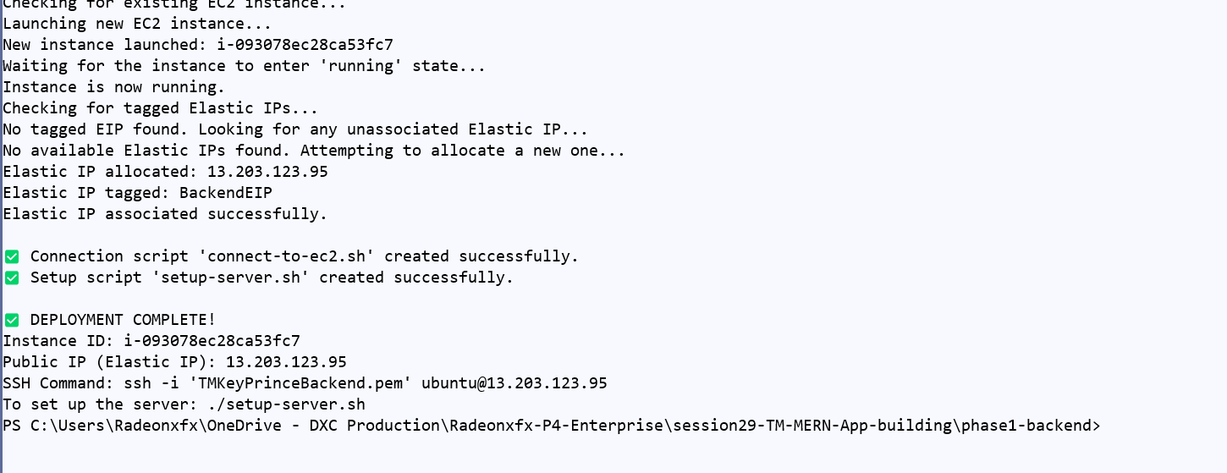
- Frontend:
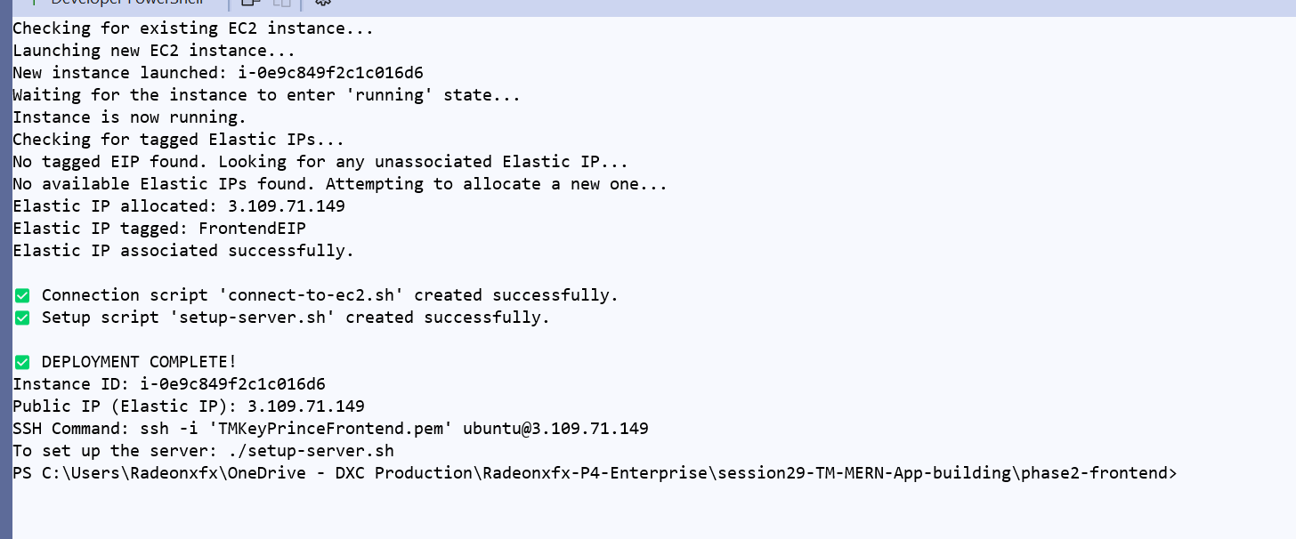

# Frontend & backend Instance will look like below:
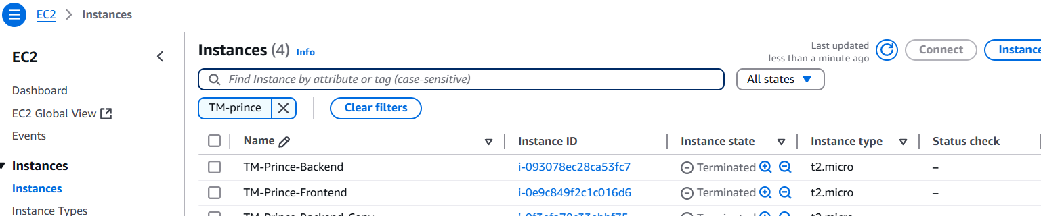
# Elastic IP’s of both instances:
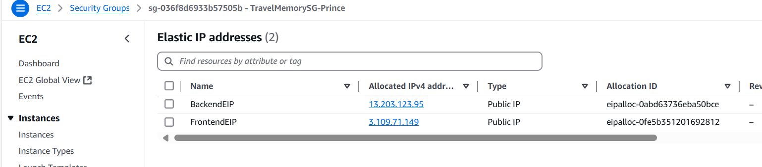
Phase2: Backend & Frontend Configuration
- 2.1 Python script will generate .ssh script to configure Ec2 with
Elastic IP:
Run script sudo ./setup-server.sh for backend & frontend

- Backend:
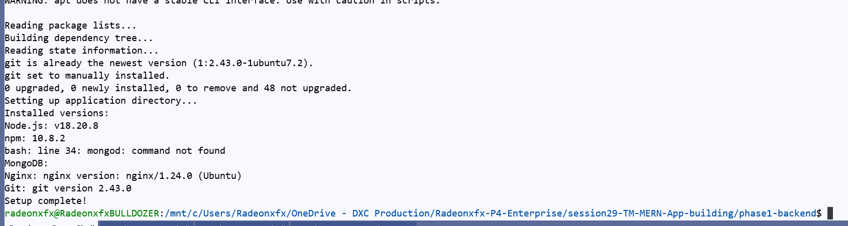
- Frontend:
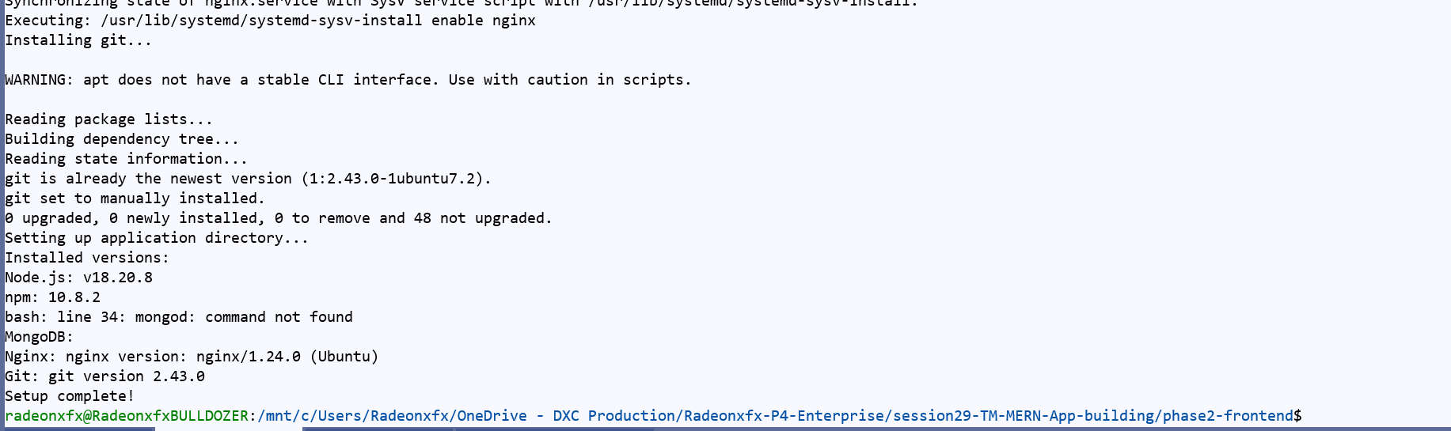

- 2.2 Clone repo and setup Backend & Frontend
#backend
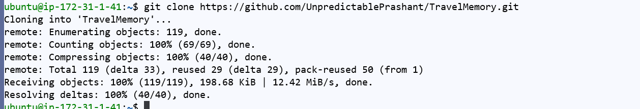

#frontend
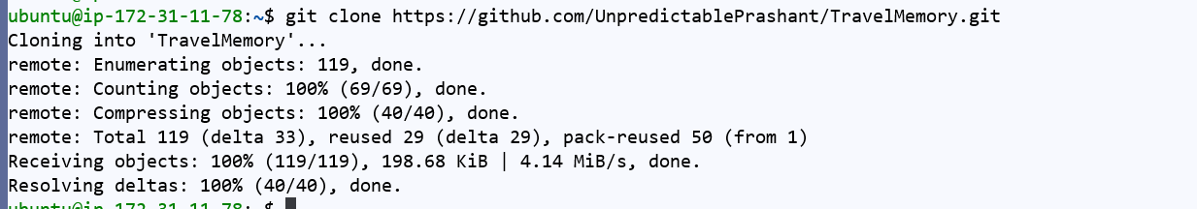

- 2.3: Update .env of backend and url.js of frontend
#updating .env of backend
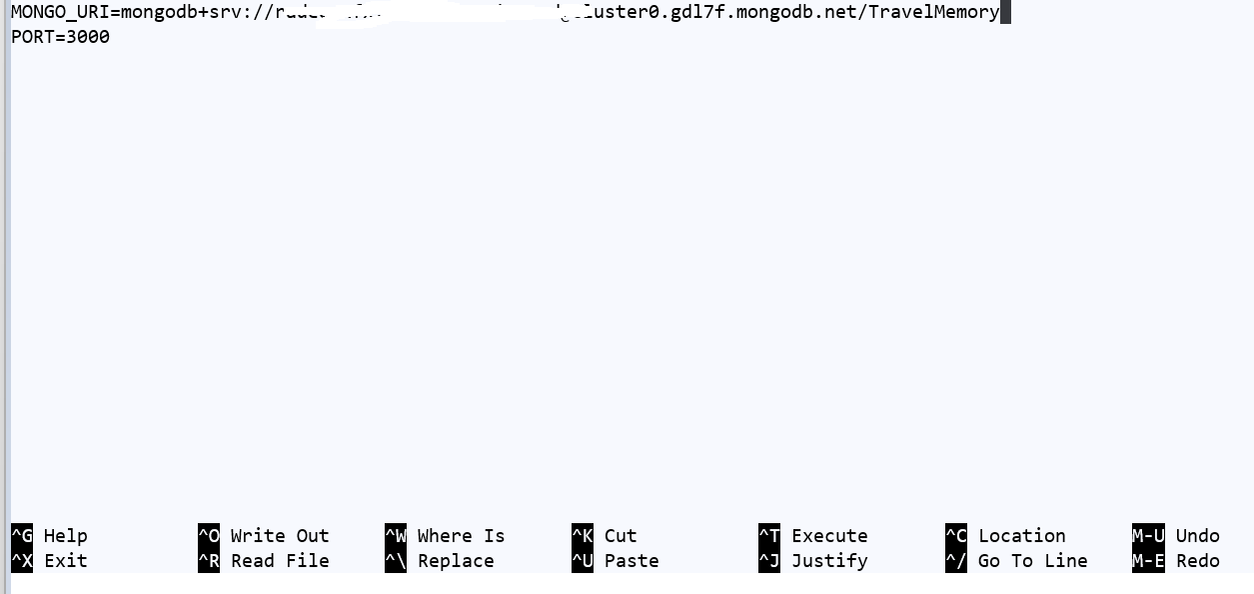
# Testing backend:
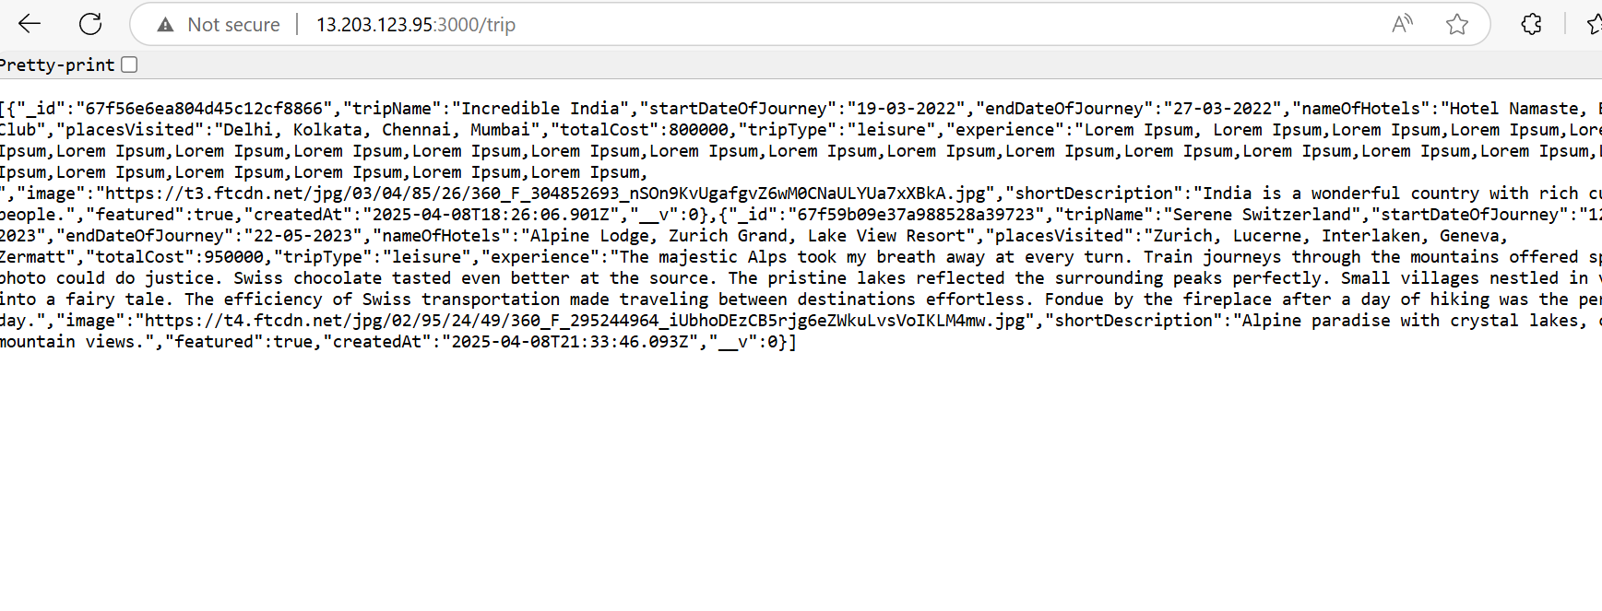

#updating url.js of frontend
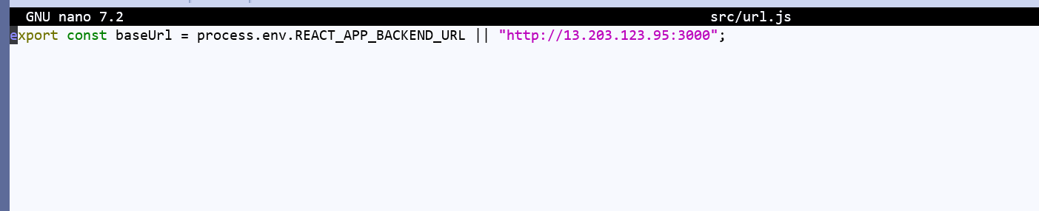

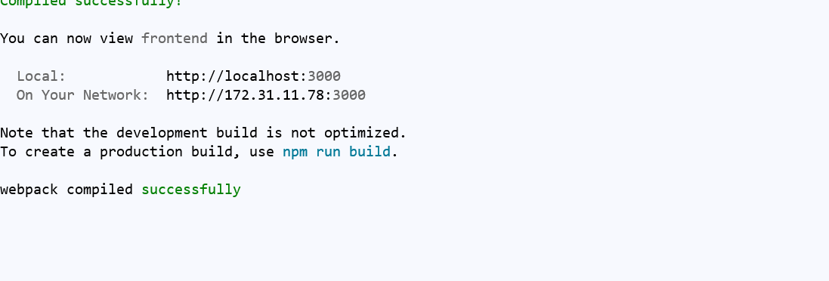
# testing frontend and backend connectivity:
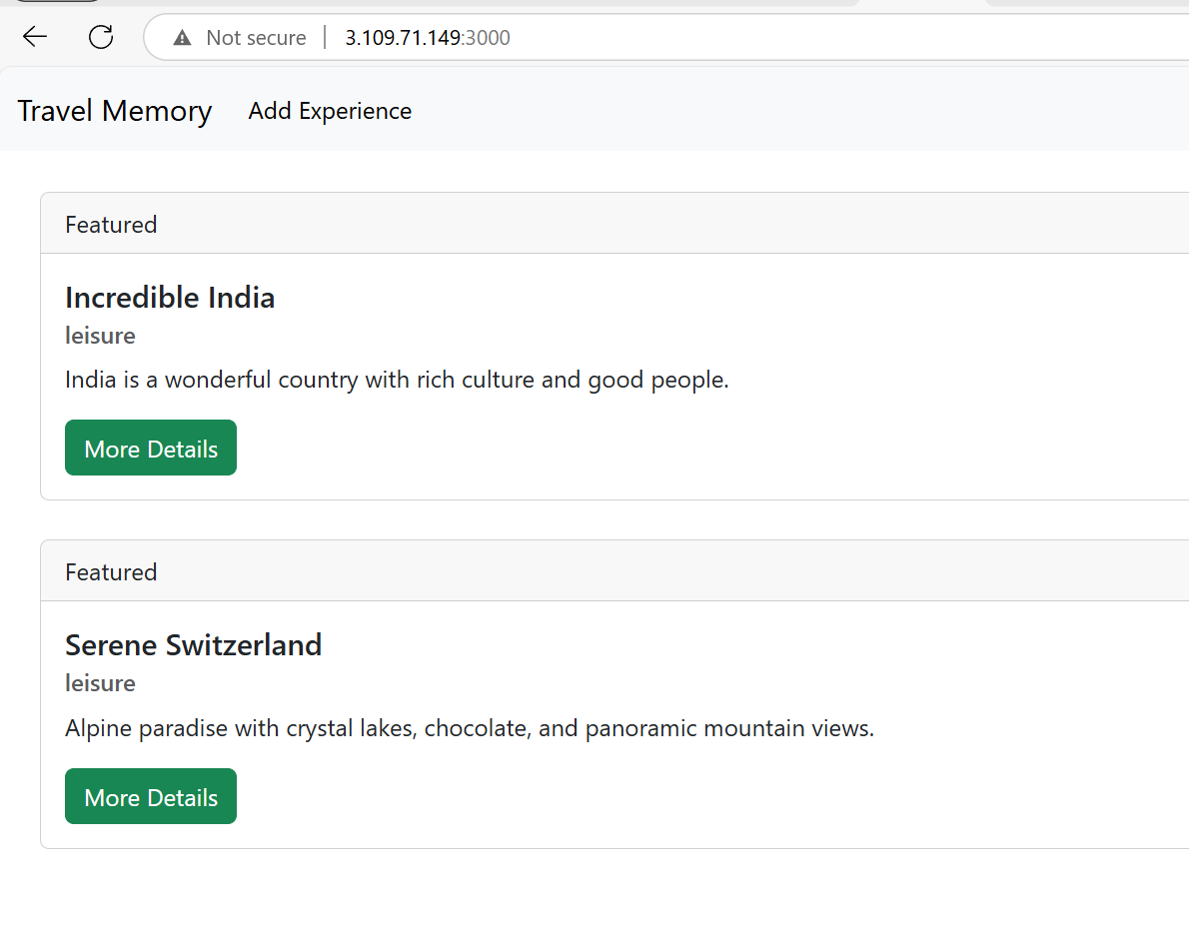

Phase3: Setup Nginx Reverse Proxy in frontend
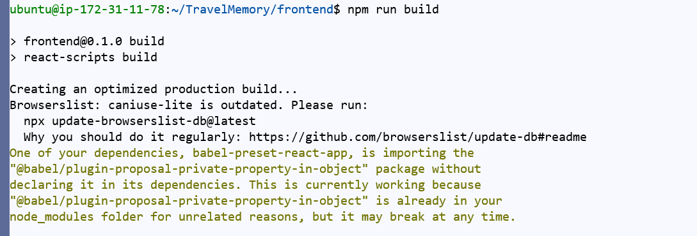
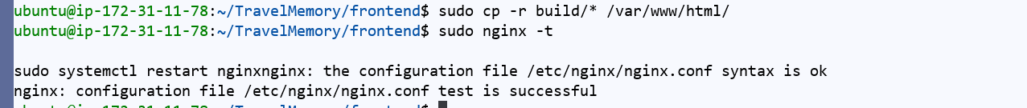

#testing Nginx frontend:
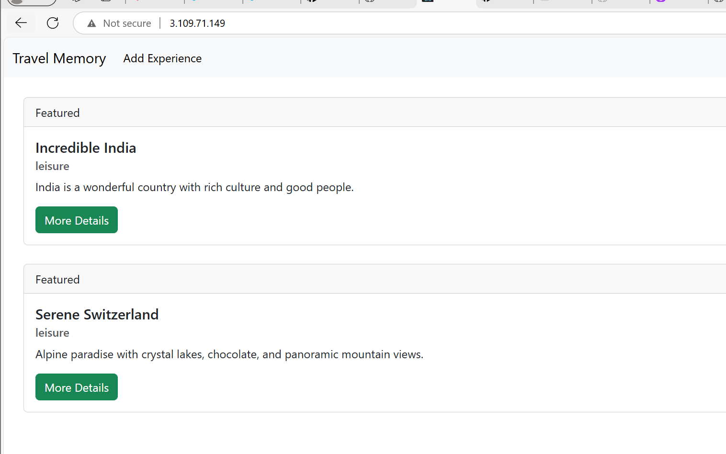

Phase4: Autoscaling instances & config
#running python script to launch new instances of frontend and backed with elastic ip:
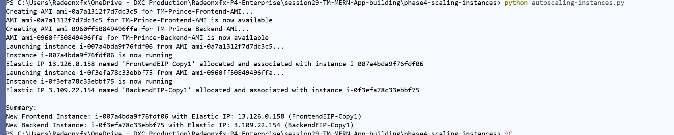
#python script will create -copy of instances
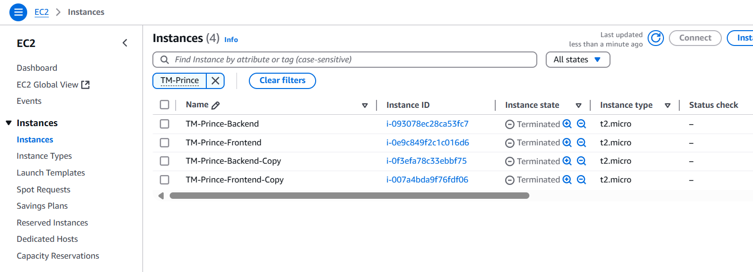
#python script will create copy of elastic IP’s
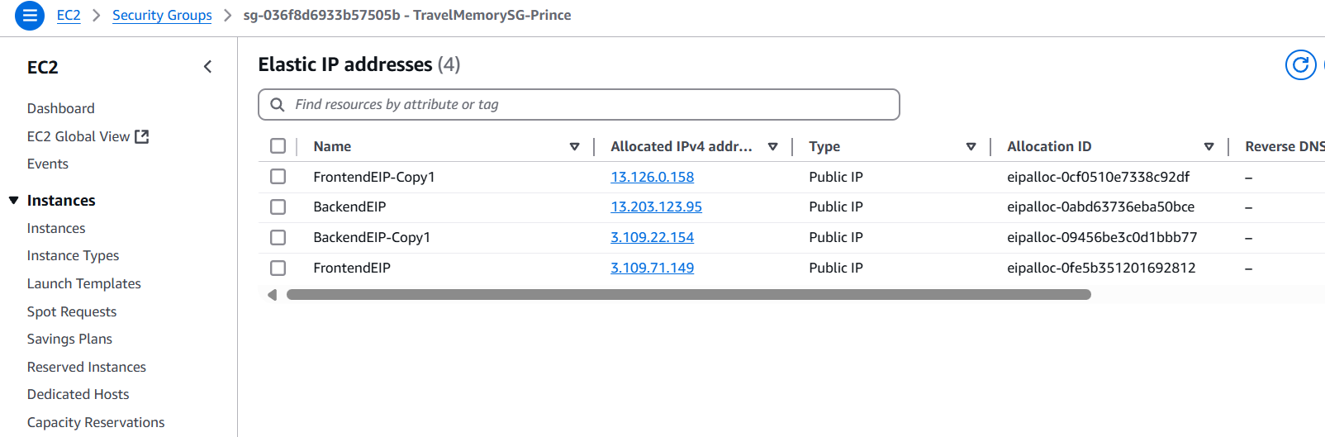

#testing backend:
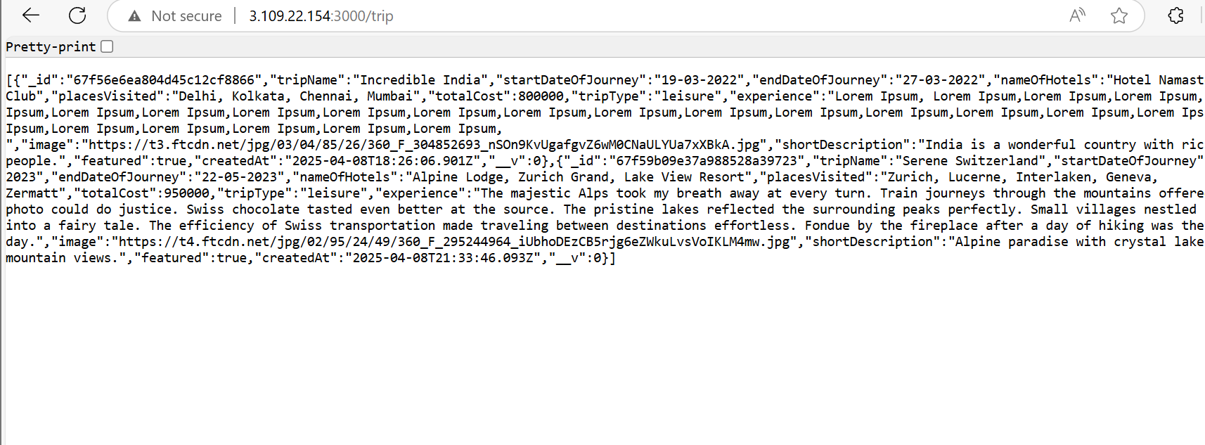
#testing frontend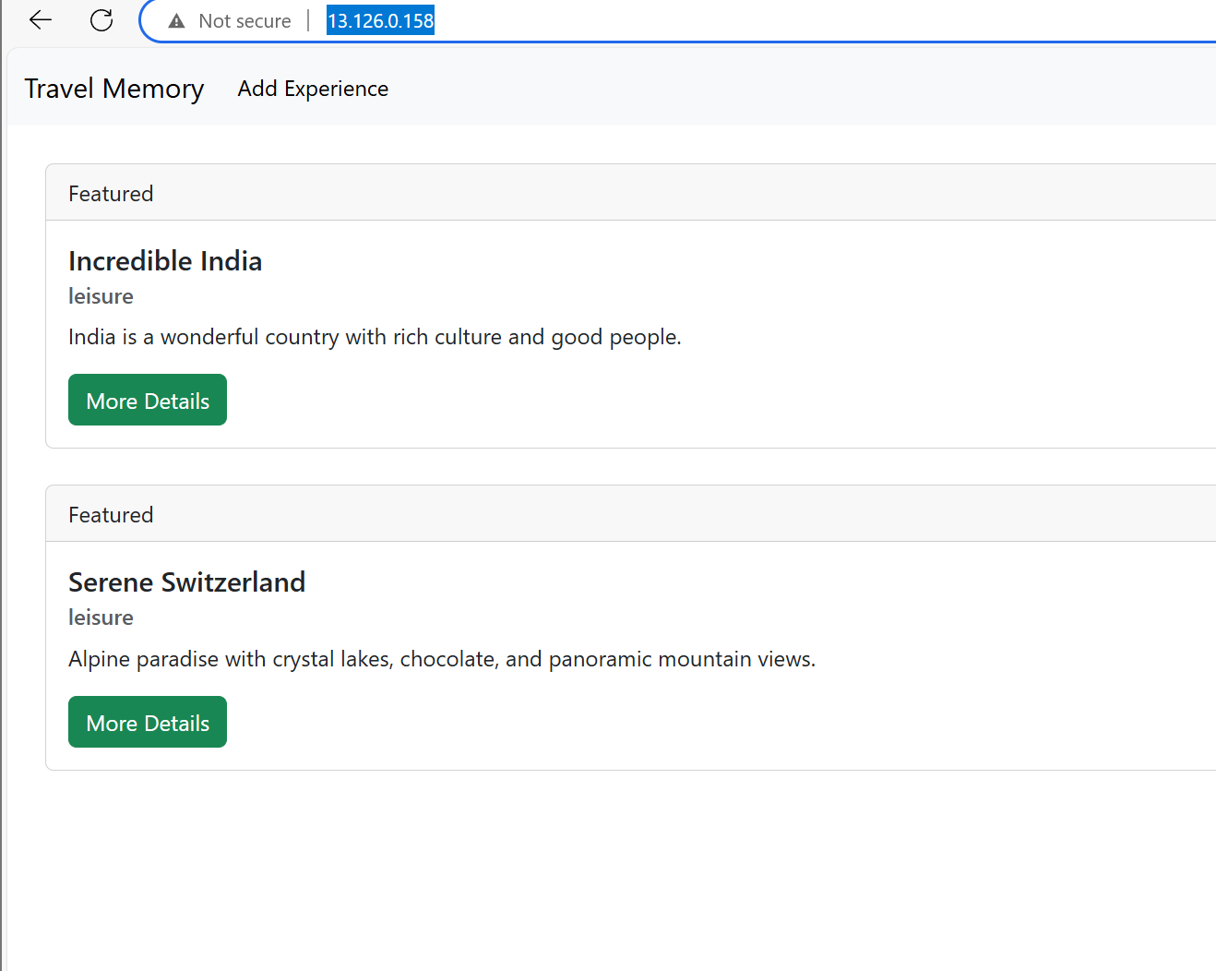

Phase5: Adding Load balancer to Frontend
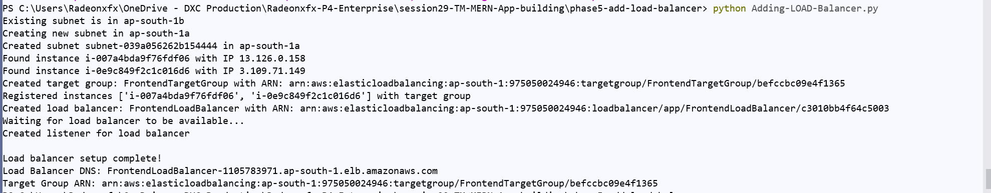

# Load Balancer Network Map
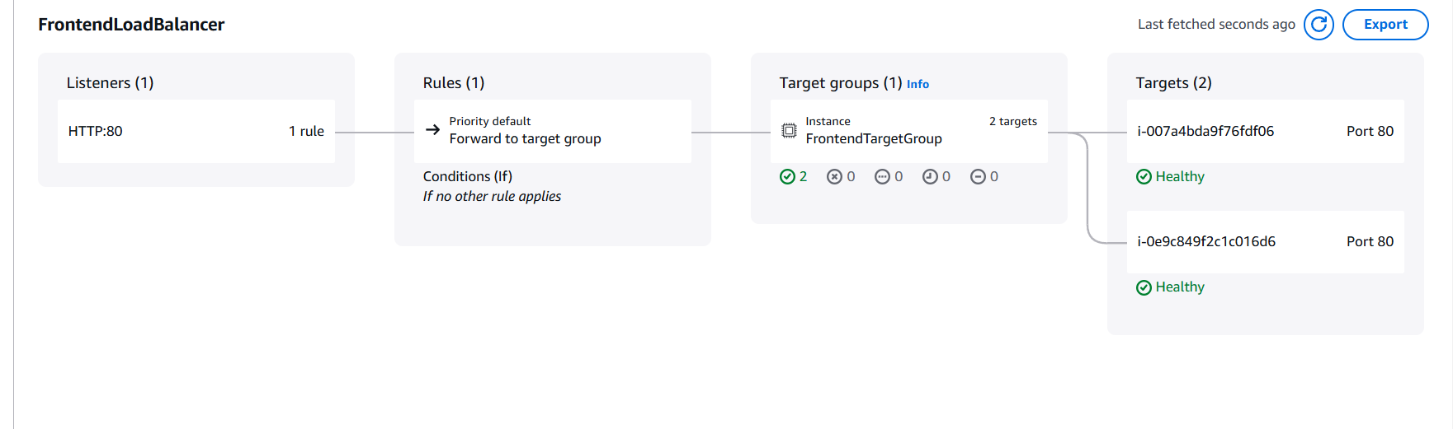
#testing load balancer:
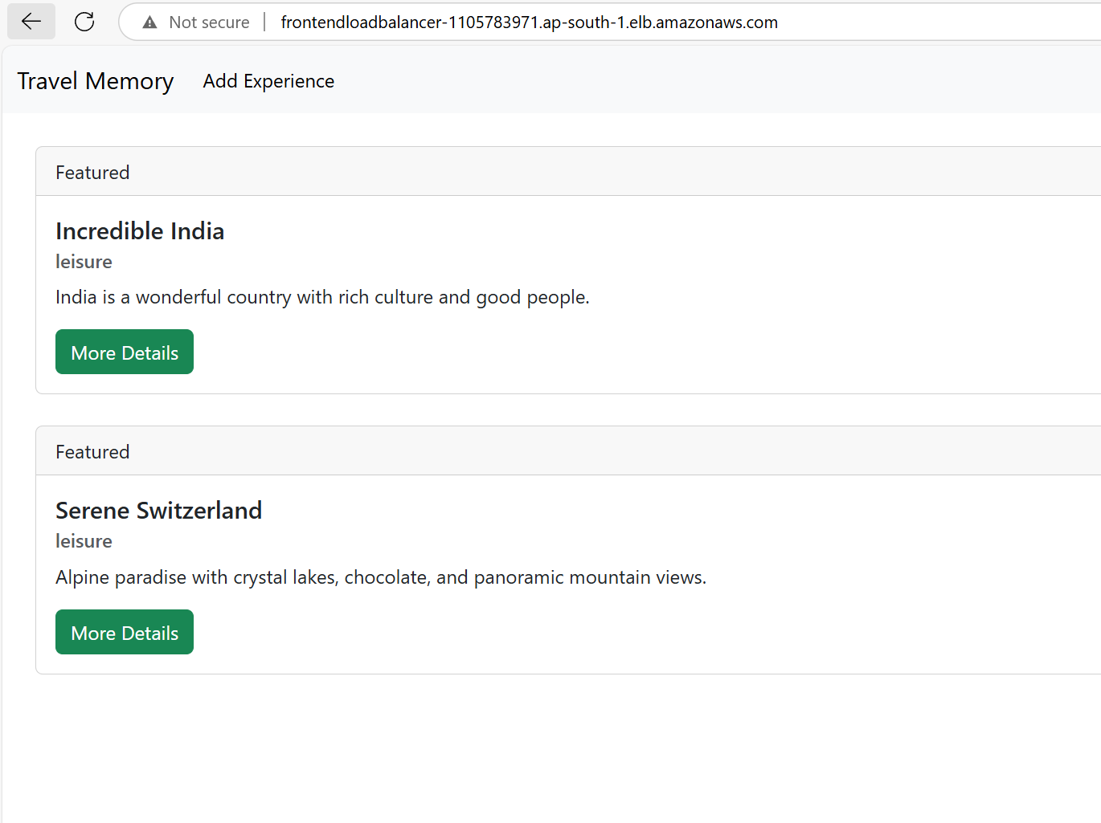

Phase6: Domain Setup with Cloudflare
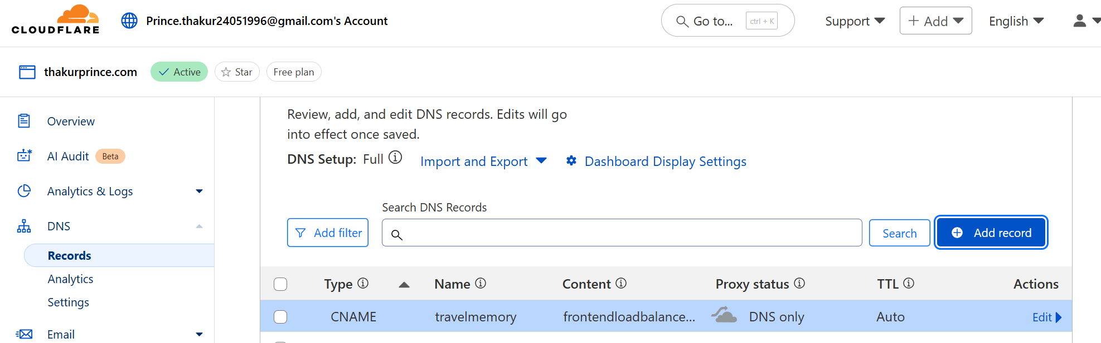

# Final testing of complete application on domain thakurprince.com and the final website is http://travelmemory.thakurprince.com
